**CC0003 / Ethics and Civics in a Multicultural World**

**Semester 1, AY2021-22**

**Accessing the Debate Team Peer Assessment Survey**

This document provides instructions on how to access the peer assessment survey for your CC0003 debate team project.

1. *Background: Peer Assessment Scores in the Debate Team Project*

Your grade on the debate team project will depend in part on your teammates’ assessments. The instructors will use the following survey to learn about how your teammates would score your contribution to the debate team project.

**The teammate made substantial contributions to the team’s debate project.**

1. **Strongly Disagree**
2. **Disagree**
3. **Neutral**
4. **Agree**
5. **Strongly Agree**

A student’s **peer assessment score** will be the average of the scores given by all his/her teammates.

Please refer to Appendix 5 of the CC0003 course outline for an explanation of how a student’s team debate grade is affected by the peer assessment score.

1. *Submitting Assessment Scores via eUreka Surveys on NTULearn*

After a debate is held, every student needs to submit an assessment score for every other student on his/her debate team.

Assessment scores are recorded using eUreka surveys on NTULearn.

To access the eUreka survey for your debate team, follow these steps:

1. Log in to NTULearn: <https://ntulearn.ntu.edu.sg/>
2. Click “NTU Tools” on the upper-right area of the NTULearn Dashboard.

1. Click **“Click HERE”** under the eUreka tool on the upper-right area of the NTU Tools screen.

1. A “Projects Home” page will open. Under “Project Name & Description,” you should find a project named after your small group and the week in which your debate was held. See the example below. Click the link to the project.

1. Click “Peer Evaluation.”

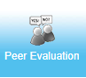

1. Click the link under “Evaluation Name.” The link is named after your small group and the week in which your debate was held.

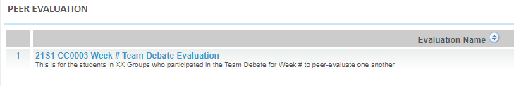

1. A page with the heading “View Evaluation” will open. Read the Rubric criteria.

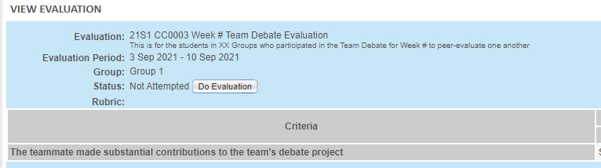

1. Click “Do evaluation.” A page with the heading “Edit Evaluation” will appear.



1. Click a score from 1 to 5 for each of your teammates. A bigger number means a higher score. “1” means *strongly disagree*, “2” means *disagree*, “3” means *neutral*, “4” means *agree*, and “5” means *strongly agree*. It is important that you be fair and impartial in your assessment, just as you would hope for your teammates to be when assessing you.

